PAAREES Perfumes

DOLCE & GABBANA Men

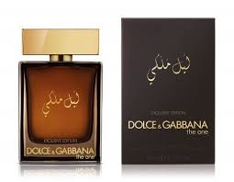

**DOLCE & GABBANA the One Gentleman for Men**

**DOLCE AND GABBANA**

(1)Key Features

* long lasting
* for Men
* 100 ml
* Eau de Toilette